**Report 1: Dissertation – Longitudinal Analysis of Farm Animal Development**

Data Description:

**Farm name** – Cragg Farm

A total of 577 lambs are present in our dataset for the year (2016-2022).

In some of the years like 2017, Sire's name has been provided with characters rather than ID (number).

Year - 2016

Type: Pedigree, Dam (Mother of Lamb), Sire (Father of Lamb)

No. Of Lambs Based on Sex – 59 (Females), 42(Males)

Data types of different columns for “lambs2016” data.

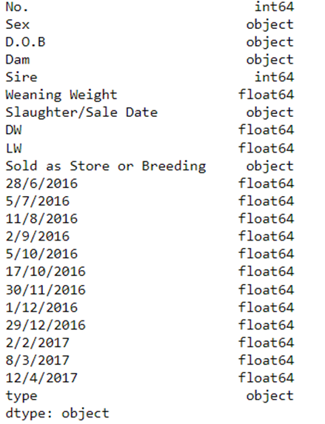

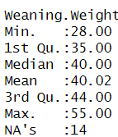 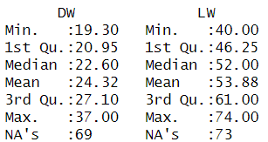

Maximum Weaning weight recorded was 55Kg while the average weaning weight of lambs is around 40Kg.

NA values in in weaning weight implies the weight wasn’t recorded for 14 lambs as per the dataset.

In the year 2016 it seems that the weight recorded for the lambs was inconsistent as there wasn’t any planned date or days on the basis of which the weights were regularly recorded. It looks random as, at times there was gap of 5-7 days whereas sometime it went to 45-50 days.

Problems:

* We don’t have the date for which the weaning weights were calculated for which we need to assume some random value.
* Missing data like weights and description if the lamb was sold, butchered, or sold for breeding.
* Weights were not observed for some male lambs which were butchered for some months even when the slaughter date was much later.
* Inconsistencies in data format for dates, Sire, and Dam columns.

Understanding the data:

* Usually, it can be seen that after the lambs are weaned the weight remains the same or decreases for the next month and gradually increases as the months pass by.
* The Average weaning weight of both male and female lambs seems to be the same at the time of weaning which is around 40. (Kg)
* We can see that most of the lambs are twins, triplets, quadruplets or even quintuplets.
* Similarly, we have lambs having same “Sire” (Father).

Missing Data:

Example: Lambs Not Slaughtered: Weights were not observed in October (17th) and November (30th). Only 9 lamb’s weights were observed in the specified months.

Handling missing data can be dealt with using imputation or removal based on the requirement.

Death or living weight was not recorded for some of the slaughtered lambs.

Growth Curve of a Lambs (Female):

Lamb Details:

Lamb ID – 438, D.O.B – 01/03/2016, Sex - Female

Here Weaning weight has been assumed to be observed on (1st June 2016).

This is the growth curve of a typical female lamb. Dam (mother) of this lamb had another lamb as a twin (Lamb ID - 440) which was sold for breeding. And then later butchered. Lamb (438 & 440) are twins.

The growth curve of this lamb can be seen below:

A similar graph can be seen for male lambs as well.

Exploratory Data Analysis:

No. of male lambs sold for breeding, butchered, not sold:

|  |  |  |  |  |  |
| --- | --- | --- | --- | --- | --- |
| **Total** | **Not Sold (Kept in the Farm)** | **Slaughtered** | **Sold For Breeding** | **Sold As Pet Lamb** | **Sold As Spare Lamb** |
| 41 | 2 | 30 | 1 | 6 | 2 |

Based on the figure and table we can see that most of the male lambs are slaughtered and stored for meat-based products.

While only one lamb was sold for breeding and 6 as pets.

2 of the lambs were kept on the farm, while one was sold as a spare lamb.

Distribution for Female Lambs:

|  |  |  |  |  |  |  |  |  |
| --- | --- | --- | --- | --- | --- | --- | --- | --- |
| **Total** | **Not Sold (Kept in the Farm)** | **Butchered** | **Breeding Shearing** | **Breeding** | **Breeding ewe** | **Sold As Pet Lamb** | **Spare Lamb** | **Sold As Spare Lamb** |
| 58 | 20 | 2 | 13 | 17 | 1 | 4 | 1 | 1 |

We can see from the pie chart and table that most of the female lambs are either kept in the farm or sold for breeding. Around **35%** of total lambs in 2016 were kept within the farm. Whereas **53%** of the lambs were sold for breeding which include shearing or early breeding (ewe). This shows the female dominance for keeping the lambs in the farm.

From these, we can conclude that only a few male lambs are sold for breeding and mostly butchered and stored. Whereas, female lambs are mostly used for breeding and kept in the farm.

Inconsistencies in Data for later Years apart from missing values:

* In 2017, we can see that it seems to be a clear pattern or interval at which the lamb’s weight were recorded. Almost an interval of 1-month (30-35 days) was seen while collecting the data.
* Only three Sire were present in 2017. Of which “Dinas” was the major contributor towards breeding and is the father of 48 lambs out of 63 in total which is around 76%.
* The distribution of lambs was 40 and 23 for males and females respectively.
* Sire named “Hamp” was seen in the data for the year 2019.
* In the year 2020 “Sire” name Humprrey was used and Sire data is missing for 26 lamb records.
* Similarly in the year 2021 Sire “humprrey” and “hurcules” were the only Sires present in the farm. While for the year 2022 only “hurcules” was the sole Sire in the Farm.

Except in the year 2016, data has been collected in the interval of 30-40 days each. (2017-2022).

The average weaning weight calculated from the whole data from 2016-2022 is: 37.61815 Kg. whereas maximum weaning weight recorded was 55 and minimum to be 21.

Average, Maximum and Minimum weaning weight recorded over the years:

|  |  |  |  |
| --- | --- | --- | --- |
| **Years** | **Average Weaning Weight** | **Max Weaning Weight Recorded** | **Minimum Weaning weight Recorded** |
| 2016 | 40.02 | 55 | 28 |
| 2017 | 44.73 | 55 | 26 |
| 2018 | 34.05 | 46 | 21 |
| 2019 | 35.99 | 46 | 24 |
| 2020 | 34.81 | 45 | 21 |
| 2021 | 36.63 | 47 | 26 |
| 2022 | 38.80 | 50 | 26 |

Weaning weight trend over the years: